Software Project Managing System

Aleksandrs Bistrovs 304542

Henrik Koster 305916

Kim Tranberg 172394

Laurentiu Mihai 304456

Astrid Hanghøj

Steffen Vissing Andersen

Software Engineering

First semester

7.10.2020

Table of content

**Background description** **1**

**Problem Statement** **3**

**Definition of purpose** **4**

**Delimitation** **5**

**Methodology** **6**

**Time schedule** **7**

**Sources of Information** **9**

**Appendices** **10**

# Background description

In our current time demand for IT solutions keeps getting bigger(Mordor Intelligence, 2020). Especially in the months following the current COVID-19 pandemic (Research Nester, 2020), where companies are forced to find new solutions that let their employees work from home (Felix Iblher, 2020).

Managing large IT projects is a very important and challenging task. There are many reasons for this, such as technology required to meet a customer's demands can be very complex, time limited development and having to stay within budget.(F. John Reh, 2019)

Development of IT solutions is a very time consuming and expensive process, and can often become even more expensive than what was estimated before the start of a project. Things like not having a clear objective, requirements changing during the development process, lack of skills required to fulfill stated requirements by the customer and poorly managed time schedules. These reasons often lead to a finished solution that does not meet the requirements of the customer, which causes further development time and expenses (Michael Bloch, Sven Blumberg, Jürgen Laartz, 2012).

Updating customers on progress of their ordered projects is a very important aspect of customer satisfaction, and keeping your customers satisfied is really important to all companies that sell a product. Otherwise “Many times, however, consumers do not complain to the company, but instead take actions such as switching brands or engaging in negative word of mouth (WOM).” (Hawkins & Mothersbaugh, 2010, p. 636)

(Demand for IT solution high)

Current demand for IT solutions is high.

(Demand for IT solution increase)

(Demand for IT it solution covid-19)

(Demand for more complex solutions)

(Complex systems difficult to manage)

(Being efficient, can satisfy demand) Competitive pricing, less timeused, less wages to be paid to employees, same quality

(Customer satisfaction) Being transparent and keeping customers updated on progress

# 

# 

# Problem Statement

Managing large software projects is a very difficult activity to do, keeping an overview of all the tasks each requirement has, the progress, who is working on it and so on. It will quickly become unmanageable.

The following sub-questions are formulated to get a better understanding of the main problem:

1. How to efficiently manage software development projects?
2. What could be done to avoid a project falling behind schedule?
3. What kind of tools should be available to the user of the system?
4. In which way should customers be able to track progress of their projects?
5. What kind of information should be available to the customer?
6. Who is responsible for the cost, when the finished product does not meet the users requirements?

# Definition of purpose

The purpose is to help Mr. Colour’s Company to manage IT development projects, so they can lower the risks involved with IT development projects, and satisfy their customers.

# Delimitation

We are not going to solve the problem about who is responsible for extra cost when projects do not meet requirements.

We will not create a solution that can manage large IT development projects.

We will not go into difficulties caused by the current COVID-19 situations, where company employees have to work from home.

# Methodology

This project will be using a modified version of the Waterfall method (Royce, Winston. 1970). The waterfall method is a top down method, which means that a phase has to be finished before the next can start. The modification of this method revolves around being able to go back and forth between the phases, if errors in the design are later discovered while doing implementation. It will be possible to go back and update the design so it matches the updated implementation, to fix these errors.

Methodology

In the given project the development team will make use of the modified Waterfall approach. It consists of 5 stages, which follow strict, linear order, where each stage has to be fully completed before moving on to the next one (Winston Royce, 1970). In order for the Waterfall model to work, the requirements have to be well-defined, otherwise it is fairly easy to fail within this approach (Rumor, 2019). Since there is no possibility to navigate between the given stages, and fix the occurred problems on the way, the team has decided to use a modified version of the Waterfall method. It is being done in order to work around the previously mentioned issue by enabling the users of the model to go back and forth between the stages and fix the errors occurred during their work.

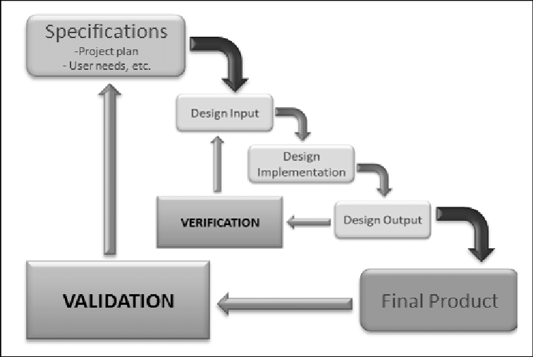

*Fig. 1. Waterfall method design process* (Koivukangas, 2015)

# Time schedule

The expected workload is 27.5 hours per ECTS per student. And SEP1 is worth 5 ECTS so the total expected workload per student is 137.5 hours. The project spans 12 weeks so each member should spend 2.3 hours working on the project each workday of each week.

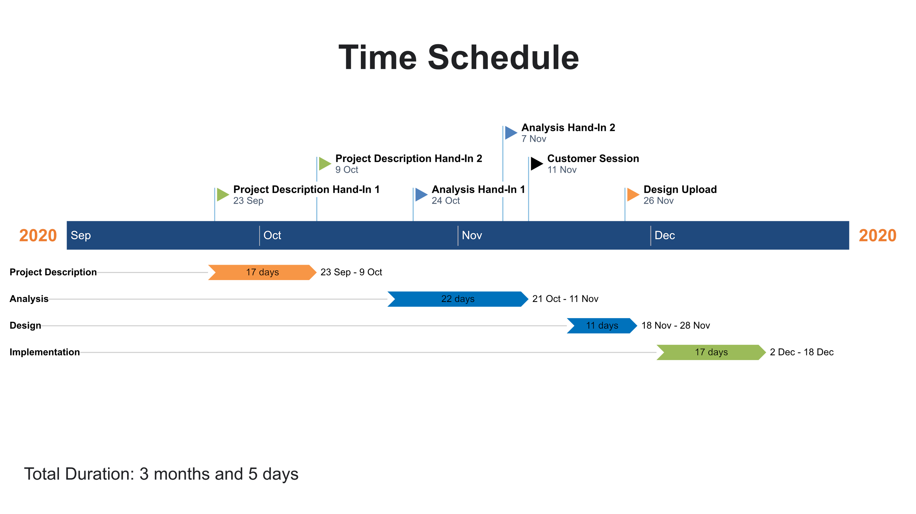

**Risk assessment**

| **Risk Assessment** | | | | | | | | | | | | |
| --- | --- | --- | --- | --- | --- | --- | --- | --- | --- | --- | --- | --- |
|
| Risk | Description | | Likelihood Scale: 1-5  (5 = high risk) | | Severity Scale: 1-5  (5 = high risk) | | Product of Likelihood and  Severity | | Risk Mitigation | | Responsible | |
|
| Risk 1 | Lack of time before  hand-in/assignment | | 2 | | 3 | | 6 | | Assign internal deadlines for specific tasks,  more classwork. | | Everyone | |
|
| Risk 2 | Late hand-in/assignment | | 2 | | 3 | | 6 | | Assign internal deadlines for specific tasks. | | Everyone | |
|
| Risk 3 | Plagiarism | | 1 | | 5 | | 5 | | Reference all third party information/sources. | | Person who plagiarized work | |
|
| Risk 4 | Unequal workload | | 2 | | 3 | | 6 | | Divide tasks evenly between team members. | | Everyone | |
|
| Risk 5 | Crunch time | | 2 | | 3 | | 6 | | Complete most important tasks early on and  leave less significant work for the end. | | Everyone | |
|

# 

# 

# Sources of Information

Del I. Hawkins, David L. Mothersbaugh. 2010. Consumer Behavior: Building Marketing Strategy. 11th ed. New York: McGraw-Hill/Irwin

F. John Reh. 2019. *How to Successfully Manage Your First Project.* [online] Available at: <<https://www.thebalancecareers.com/how-to-successfully-manage-your-first-project-2276127>> [Accessed 8 Oktober 2020]

Felix Iblher, Andreas Oberlaender, Hendrik Willenbruch, Hugues Havrin. 2020. *It services: Who will win when demand bounces back*? [pdf] available at: <<https://www.oliverwyman.com/content/dam/oliver-wyman/v2/publications/2020/jun/IT_services_Who_Will_Win_When_Demand_Bounces_Back.pdf>> [accessed 8 Oktober 2020].

Michael Bloch, Sven Blumberg, and Jürgen Laartz. 2012. *Delivering large-scale IT projects on time, on budget, and on value.* (online) Available at: <<https://www.mckinsey.com/business-functions/mckinsey-digital/our-insights/delivering-large-scale-it-projects-on-time-on-budget-and-on-value#>> [Accessed 8 Oktober 2020]

Mordor Intelligence. 2020. *IT Services Market - Growth, Trends, and Forecast (2020 - 2025).* [online] Available at: <<https://www.mordorintelligence.com/industry-reports/it-services-market>> [Accessed 8 Oktober 2020]

Research Nester. 2020. *IT Managed Services Market: Global Demand Analysis & Opportunity Outlook 2023.* [online] Available at:

<<https://www.researchnester.com/reports/it-managed-services-market-global-demand-analysis-opportunity-outlook-2023/336>> [Accessed 8 Oktober 2020]

Royce, Winston. (1970). *Managing the Development of Large Software Systems*. [pdf] Available at: <<http://www-scf.usc.edu/~csci201/lectures/Lecture11/royce1970.pdf>> [Accessed 8 Oktober 2020]

Koivukangas Tapani. (2015). *Streamlining Medical Device Design Development Process from Research Laboratory to the Market.* [pdf] Available at: <<https://www.researchgate.net/publication/274570349_Streamlining_Medical_Device_Design_Development_Process_from_Research_Laboratory_to_the_Market>> [Accessed 17 November 2020]

# Appendices